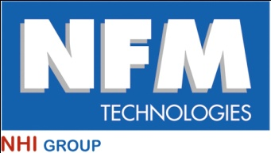

Press Release

Lyon, Monday, 14 April 2014

First contract for NFM Technologies in Saudi Arabia

**NFM Technologies has just signed an agreement with the Metro Riyadh line 3 limited" consortium to supply a 10.16 m-diameter tunnel boring machine to excavate the red line of the Saudi capital's metro system.**

The consortium features companies such as Impreglio SpA, Larsen & Toubro Limited and Nesma & Partners Contracting Co. Ltd. It is responsible for building the 40.7 km of line 3, the longest of the project. Line 3 runs in the East-West direction across Riyadh, with 20 stations and a 6 km underground section.

To excavate the tunnel, NFM Technologies will supply an earth pressure balance tunnel boring machine. Weighing 1400 tonnes and 100 m long, the boring machine will excavate at a maximum depth of 40 m, in soil mainly composed of limestone and loam.

The machine will be built, assembled and tested in the NFM workshops in Le Creusot, Burgundy. Delivery to the client is scheduled for this summer.

*****

NFM Technologies

5 place Jules Ferry

69456 Lyon cedex 06

France

web:

www.nfm-technologies.com